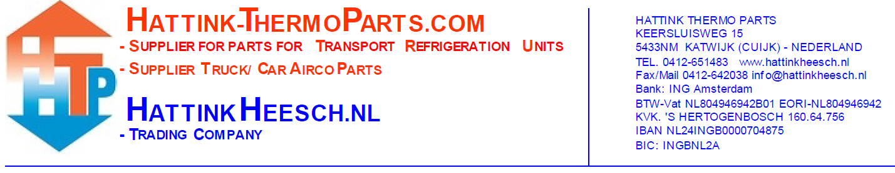Request Return

|  |  |  |  |
| --- | --- | --- | --- |
| Number | Articlenumber | Receiptnumber | Reason of return |
|  |  |  |  |
|  |  |  |  |
|  |  |  |  |
|  |  |  |  |
|  |  |  |  |
|  |  |  |  |

**Comments:**

**Your data:**

Company name:

Contact:

Customer number:

In case of approval of the returned items by one of our employees, we charge the following costs:

A minimum of 15,- euro administration costs are charged. Additional costs are charged percentage wise as stated below:  
  
**10% cost (return within 7 days)**of the net price from the order will be deducted, paid or credit note.  
**15% cost (return within 14 days)** of the net price from the order will be deducted, paid or credit note.  
**25% cost (return after 14 days)** of the net price from the order will be deducted, paid or credit note.

**Articles which receive no consideration for exchange or restitution:**   
 - Consumption products as refrigerant, kit, refrigerant oil;   
 - Articles that are used, damaged or incomplete;   
 - Electrical components/parts as printboards, thermostats, control cabinets, sensors, switches, Fans/Blowers 12V/24V etc.;  
 - Orders that are ordered especially for you and articles that are made especially for you.

**Pay attention:**   
 - No guarantee on seals and driers/filters for both original and imitation;  
 - The articles that you send back needs to be insured;  
 - It is important that the product is complete, unused and that it is in the original and undamaged packaging;  
 - Unstamped postal packeges will be not received;   
 - You pay the mailing costs and the payment costs of the webshop, these will not be refund or creditted;  
 - Without approval and return number from Hattink Thermo Parts no return.

You can find information about returns on our website among ‘Customer service’.  
([www.hattink-thermoparts.com/customerservice](http://www.hattink-thermoparts.com/customerservice))